**Registry Monitoring**

The **Dashboard - Registry** page displays selected Registry values from your servers & workstations that have the Goliath Agent installed. From this page, you can also specify which Registry values you want to monitor. The display will automatically refresh every 5 minutes.

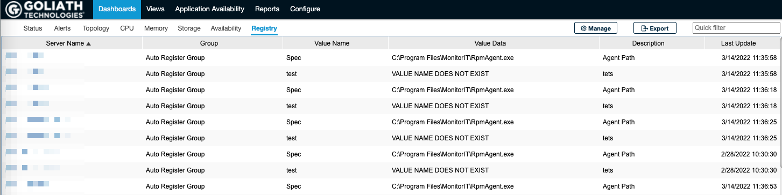

**Configure/Modify Monitoring**

1. Click the **Manage** button to modify and create which Registry settings will be monitored.
2. The **Manage Registry Monitoring Specifications** dialogue box will appear
3. To remove an existing registry value from monitoring, select the line item for it and click the **Delete** button
4. To modify an existing registry value being monitored, select the line item for it and click the **Edit** button
5. To create a new registry value to be monitored, click the **Add** button or chose an existing registry configuration and click the **Duplicate** button
   1. In the **Value Name** field, specify the name of the registry value you would like to monitor
   2. In the **Registry Key** field, specify the path of the registry key where the value resides
   3. In the **Description** field, specify an optional description to describe what the value represents
   4. In the **Check Every** field, specify the frequency in which the technology will check the registry value, in minutes
   5. The **Set Frequency for All Entries** checkbox, when checked, will override the current **Check Every** setting for all of your other configurations to the setting defined with this registry value.
   6. Click **OK** to save the configuration
6. To exit the **Manage Registry Monitoring Specifications** dialogue box and return to the main Registry page click the **Cancel** button
7. To enable alert notifications for all of the registry monitors configured, see the article for configuring an [Agent Watch Monitoring Rule](https://support.goliathtechnologies.com/hc/en-us/articles/4831026126743)